Network Drawing of International Plastics WAN
Insert name
Course code
Institutional affiliation
Instructor’s name

Network Diagram design and analysis
The current network setup for the company involves the use of a T2 internet link from its MI, Pontiac and Albany, NY branches to its Headquarters. The Chinese branch is also linked to the corporate headquarters via a T3 link as shown in figure 1, 2 and 3 below. These links are very basic, slow and unsecured and should be upgraded to more secure technologies. The Chinese link also has a satellite link to enable a redundant connection to other branches.
Risks
The network in its current configuration is risky and is exposed to availability risks due to the unreliable T1 and T2 links (Canavan, 2001). T1 and T2 leased lined are also expensive to maintain and are subjected to frequent downtimes. T1 and T2 technologies are also easy to intercept and manipulate unlike Fiber and VPN links. What the company needs is a dedicated Fiber Link between the branches. The infrastructure currently relies on old equipment and this makes the ease of catastrophic failure, lack of support and hacker attacks to increase. Diagram 4, 5, 6 and 7 presents what should be done in order to secure the connections and improve their operations and risk profile. The firewalls must also be appropriately configured.
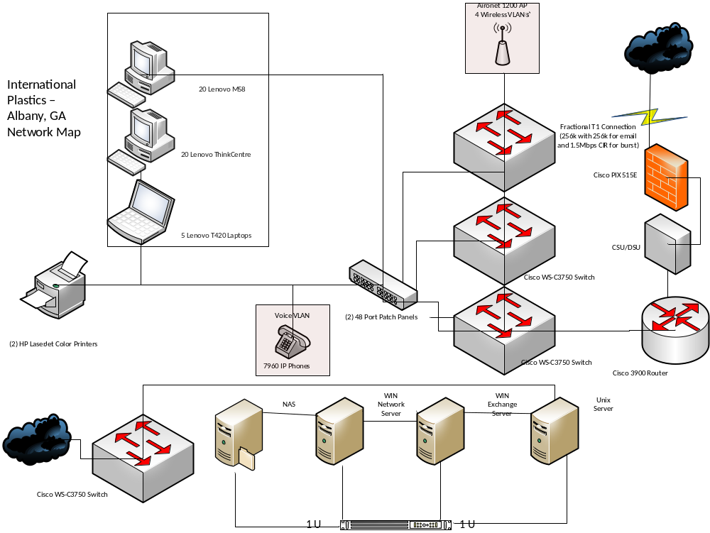
Figure 1.

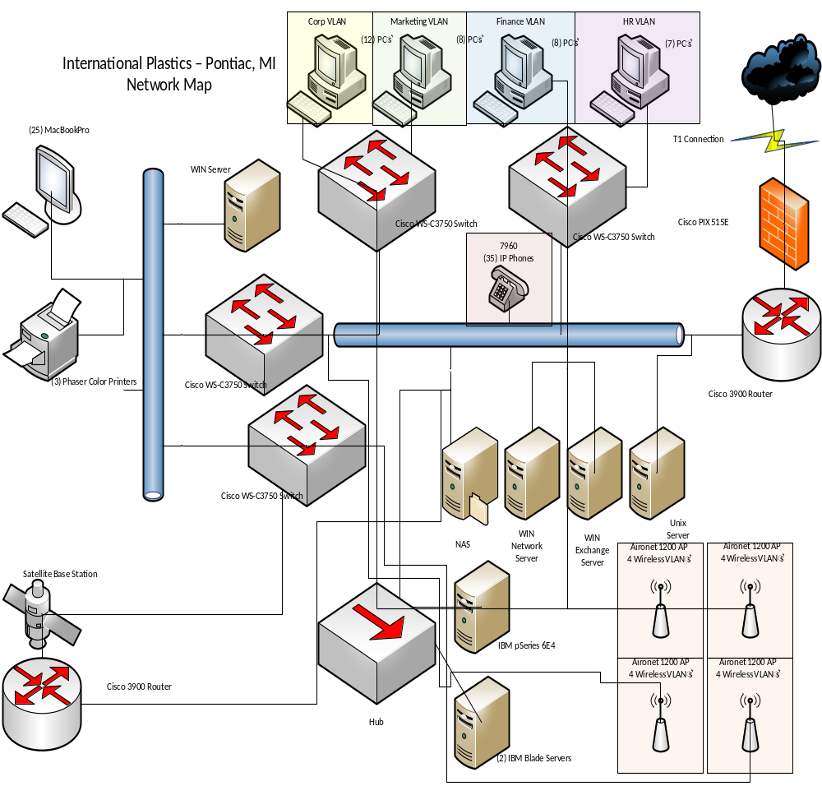
Figure 2

Figure 3

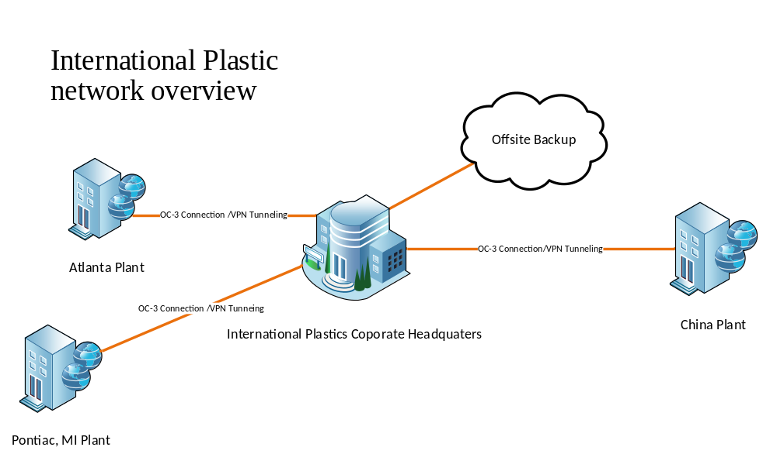
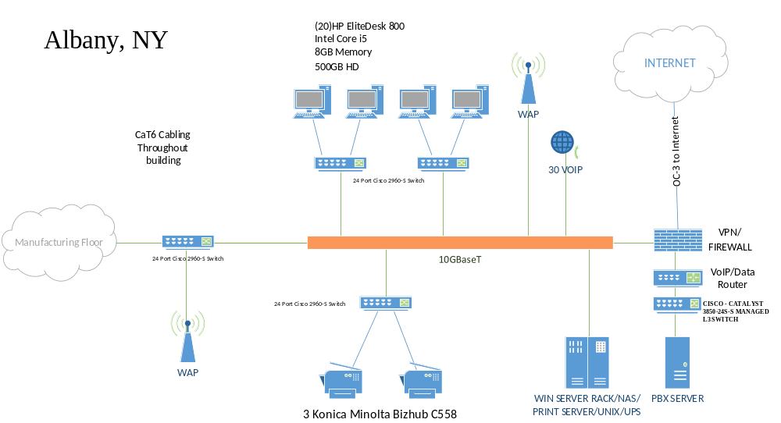

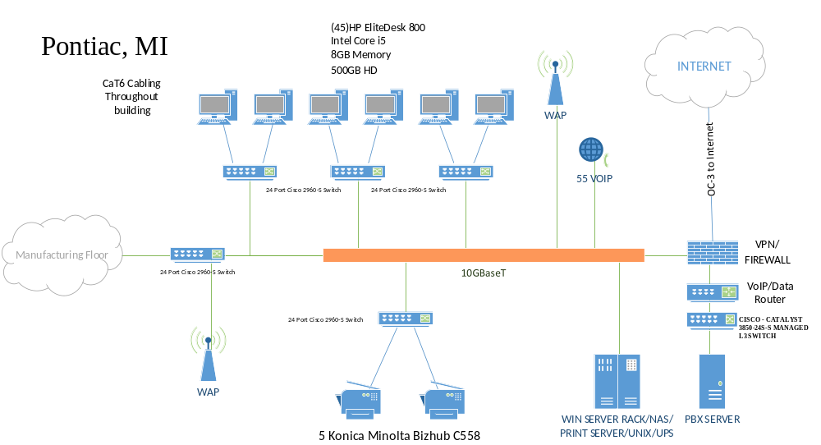
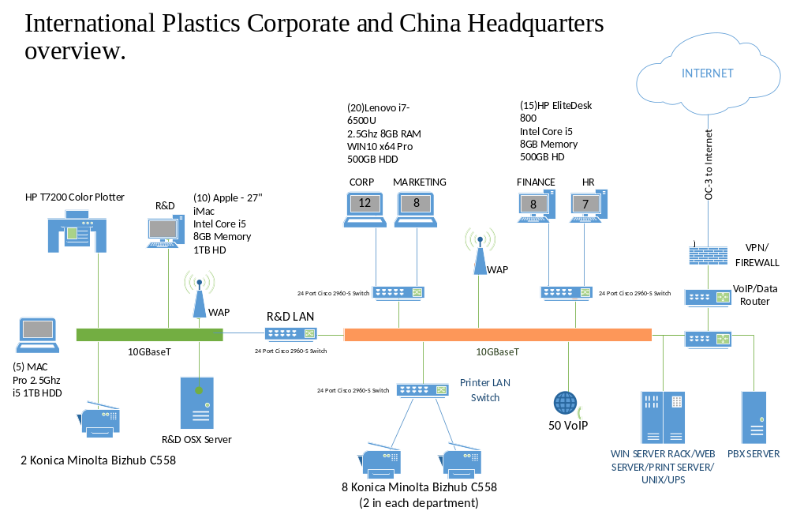
Improvements
The improvements that should be made to improve the risk profile of International Plastics WAN infrastructure includes the conversion of the T1 and T2 links into dedicated OC-3 links with dedicated VPN tunneling. All the connections should be standardized to OC3 links with VPN capability. In order to increase bandwidth, the backbone will be upgraded to 10GBaseT with robust Cat6 cabling to all desktops (Dadarlat, 2008; Stallings, 2001). New computers should also be included in the new infrastructure as shown n figure 5,6 and 7. Secured wireless points should also be added to the infrastructure to enable mobility within the organization

References
Canavan, JE (2001). Fundamentals of Network Security, Artech House, Boston, London
Dadarlat, V (2008). Types of Computer Networks and their Topologies, Cisco based computer
Networks
Stallings, W (2001). Cryptography And Network Security Principles And Practice Fifth Edition,
Prentice Hall

